
THE UNIVERSITY AZAD JAMMU AND KASHMIR
DEPARTMENT OF SOFTWARE ENGINEERING TECHNOLOGY

NAME: Uzma Khadim
ROLL NO: 2025-SET-01
SUBJECT: Programing Fundamental
COURSE CODE: CS-1104
SUBMITTED TO: Engr.Zeeshan Rashid

Lab Task 2
- Design a student ID card layout using escape sequences

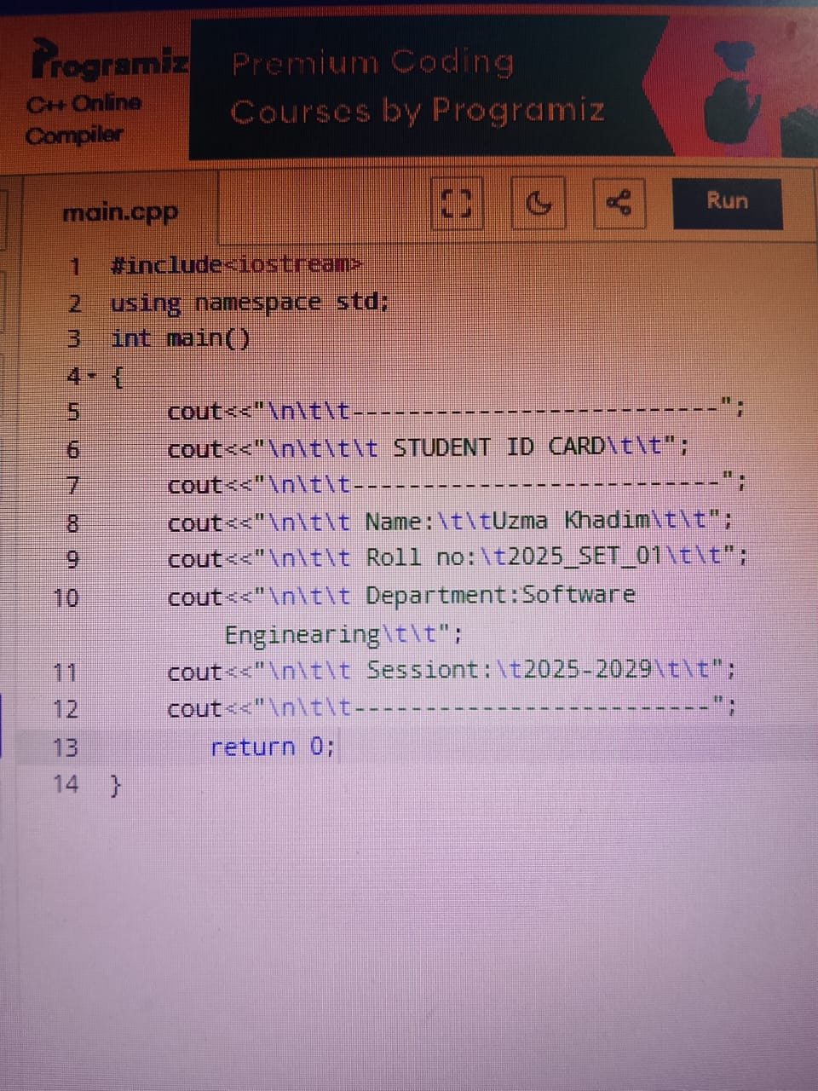

OUTPUT:
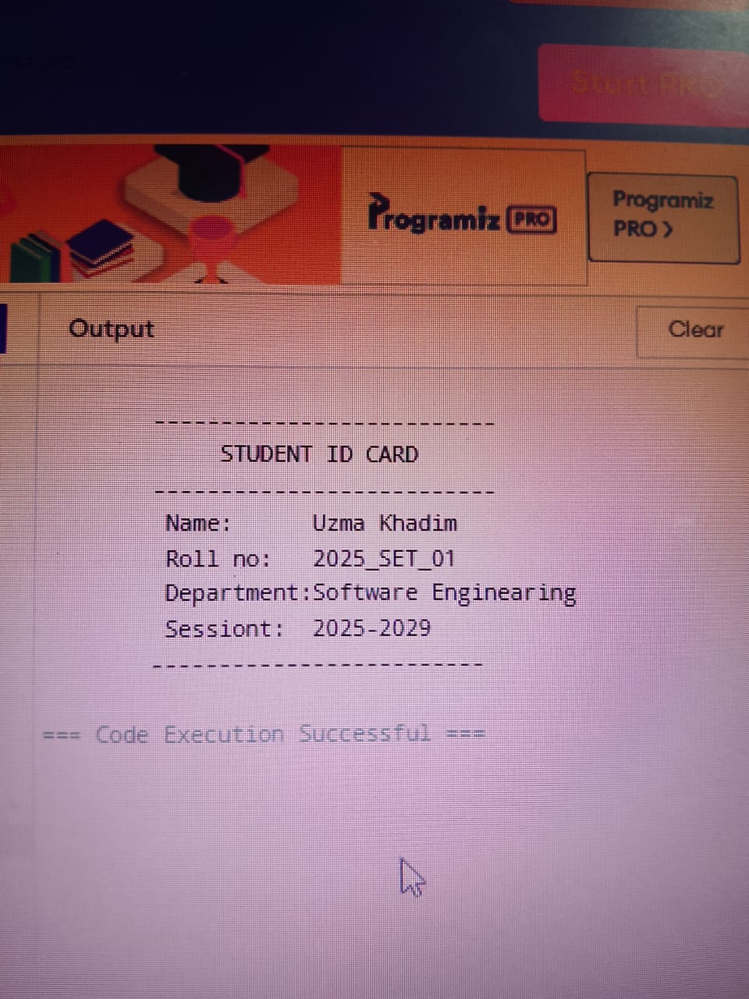

2.
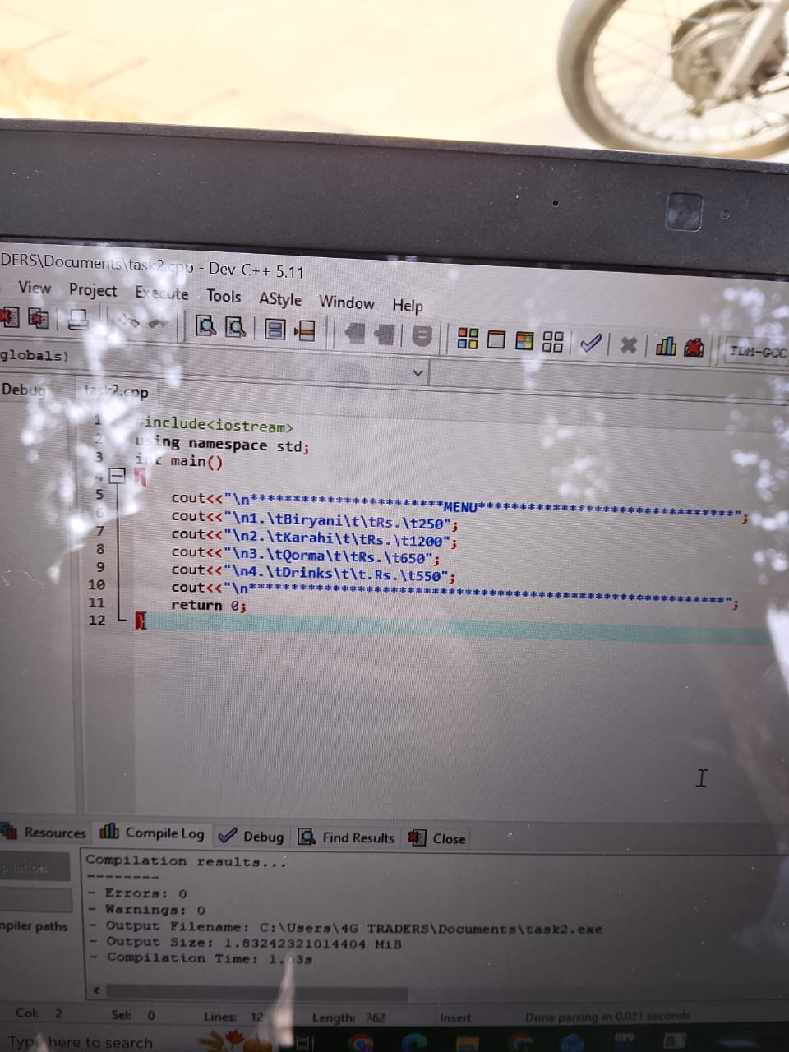
Output:
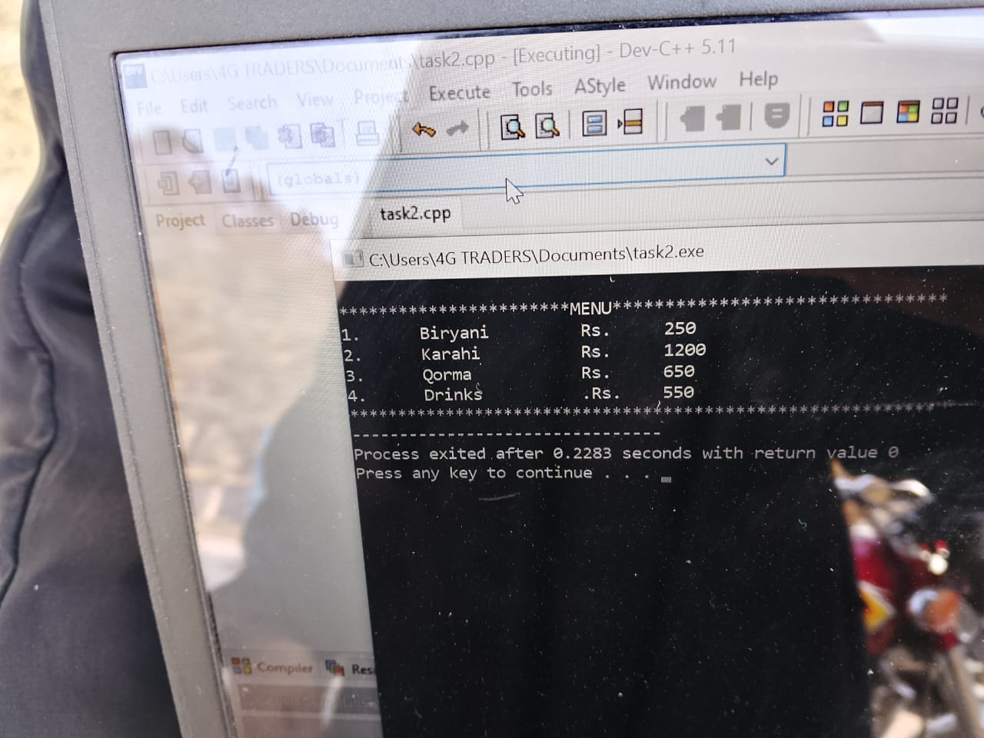
3.
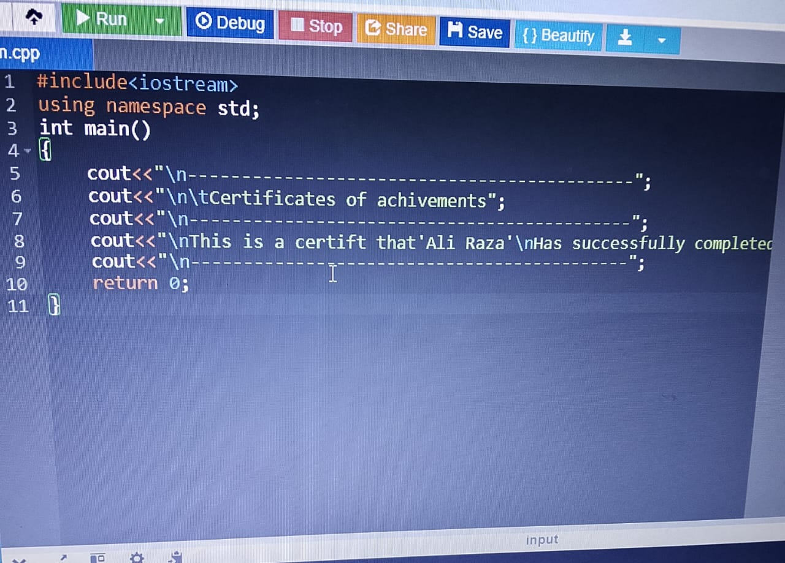

Output:
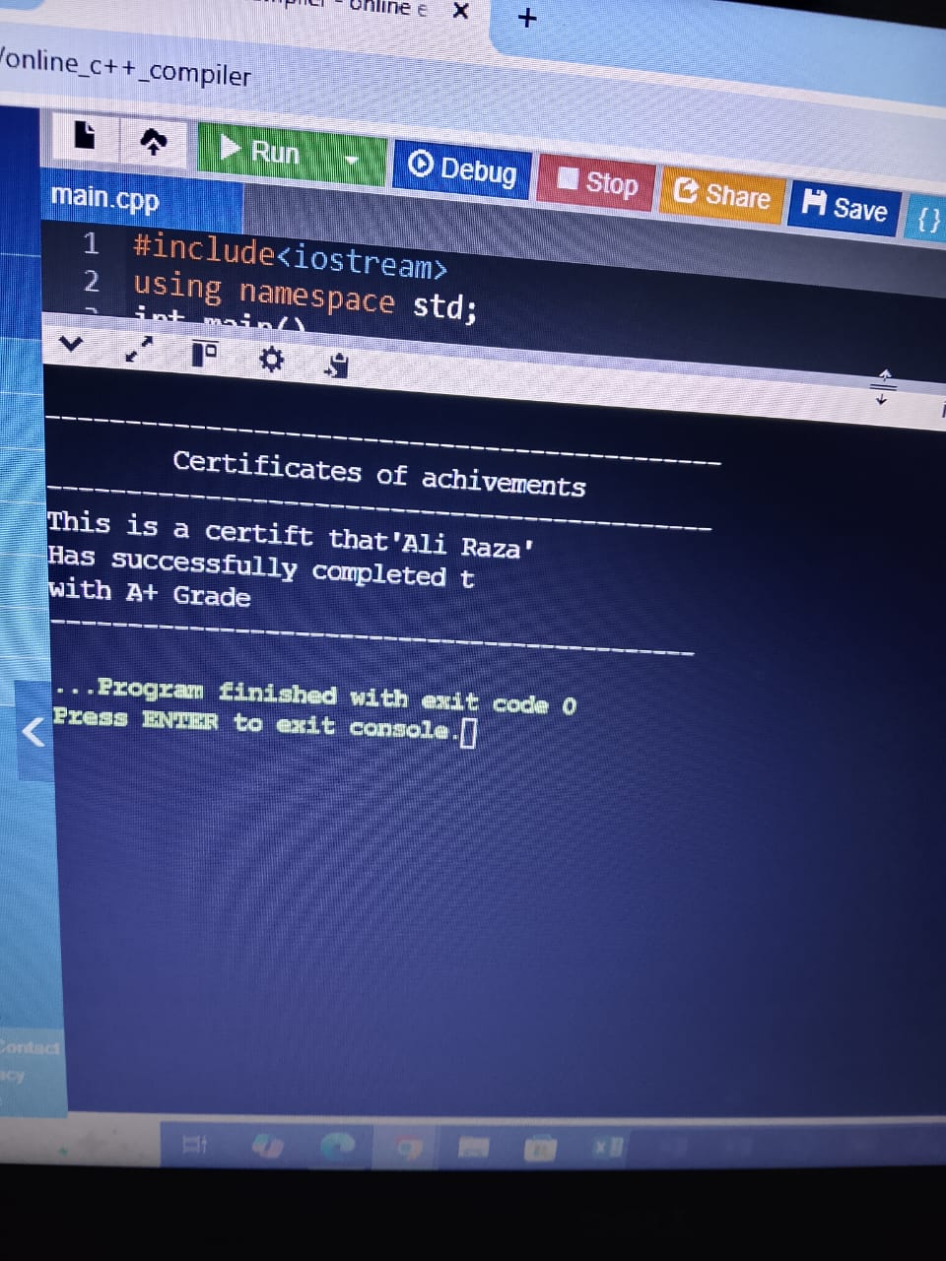

4.
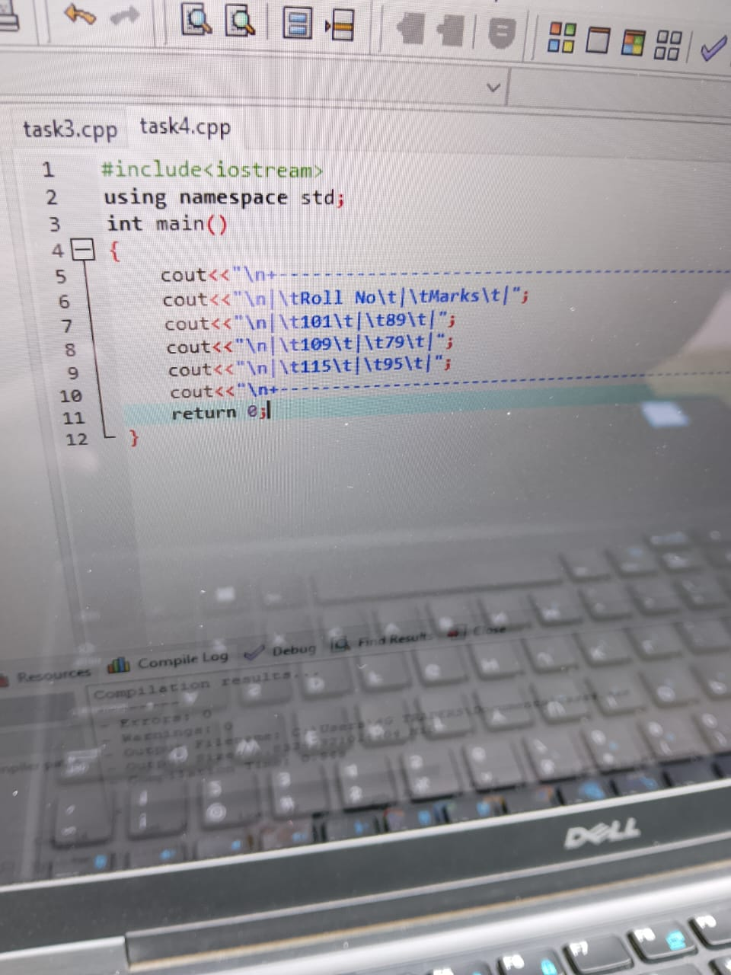
Output:
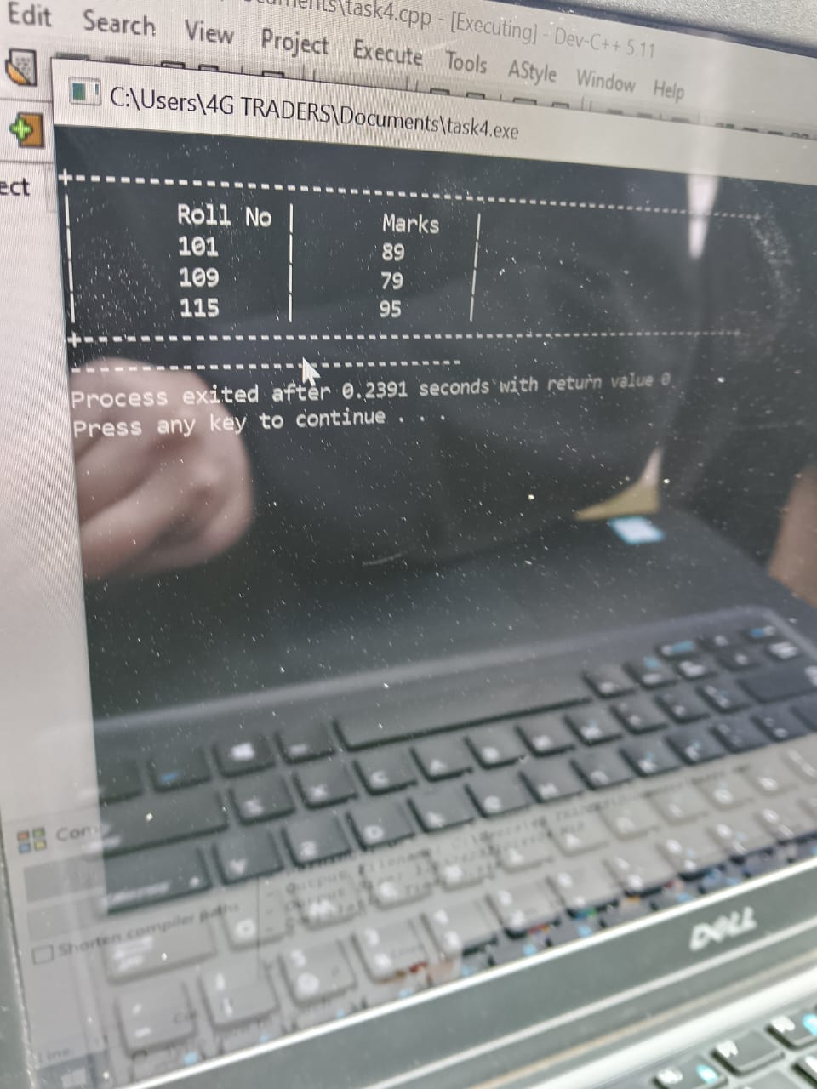
Q No.2 : Student Result Card (Using cin, cout & Escape Sequences) Takes input from the user using cin. Displays a formatted Result Card using cout and escape sequences for alignment and spacing.
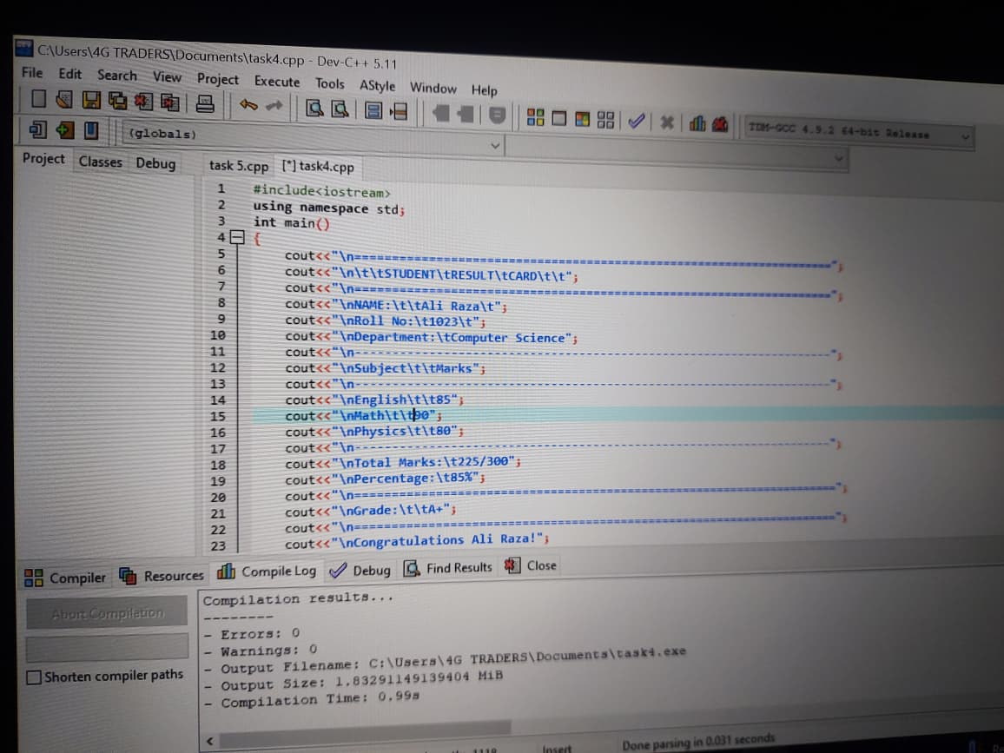
Output:
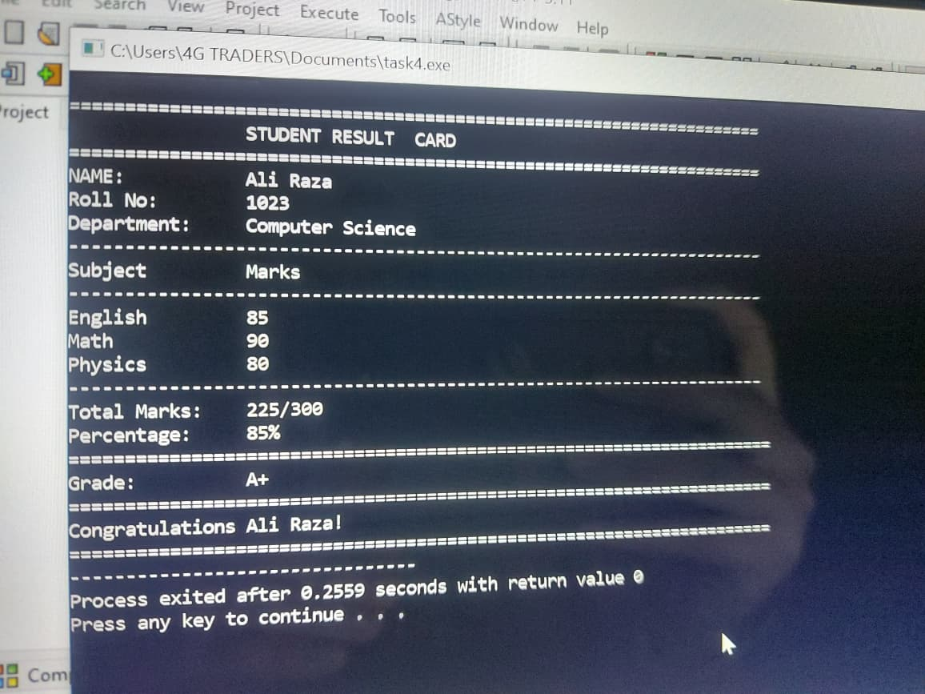

The End

